Application for SAC Registered Clinical Supervisor (RCS) must be submitted electronically via email to admin@sacsingapore.org with the relevant supporting documents. SAC Secretariat will conduct the first round of review to ensure that all the documents submitted are in good order before it will be submitted to the Clinical Supervision Board (CSB) for evaluation. The entire process generally takes about one (1) to two (2) months on average.

Select your current Membership Category:
Member ID:

- Fellow Member
- Master Clinical Member
- Clinical Member (Registered Counsellor)

Personal Information

Dr / Mr / Mrs / Ms / Miss / Mdm | Full Name as per NRIC / Passport
(Write name in BLOCK letters. Underline family name.)

Email:

Mobile No.: |  | Office Tel.: |  | Home Tel.:

Block / Street Name |  | Unit No.:

Building  (if any) |  | Country |  | Postal Code

Employer:

REQUIREMENTS
- A one-time non-refundable admin fee of SGD50.00 is applicable.
- The individual must possess at least three (3) years post SAC Registered Counsellor status
- The individual must be a current SAC Registered Counsellor (RC) with membership fees paid up to date
- The individual must have at least five (5) years of experience as a professional counsellor. This will be fulfilled in the clinical experience section below.
- Minimum one thousand five hundred (1500) post-graduation Practice/Clinical Hours, of which at least fifty (50) hours were for the provision of supervision (which can only be clocked during/after the training in clinical supervision)
- Provide log sheets demonstrating minimum 1,500 post-graduation practice hours, of which at least fifty (50) hours were for the provision of supervision.
- Log sheets must be endorsed by the Head of Organisation or equivalent. Clinical Supervisors can endorse such logs only if s/he is a staff member of the Organisation and authorised by the Head to do so.
- Minimum 100 hours of supervision received.
  - Provide log sheets demonstrating a minimum of 100 hours of supervision received.
  - Log sheets must be endorsed by the Clinical Supervisor, who is RC/RCS/equivalent.
- Minimum fifty (50) hours of Training in Supervision
- Certificate OR Letter of Attendance for each workshop/course is required (PDF)
- Possess a valid Professional Indemnity Insurance (“PI”) coverage from your company or be insured under SAC’s AIG Group Insurer (New Requirement w.e.f. March 2015 – Please see Article 5.5 of the SAC Constitution). You can also apply for exemption by completing an exemption form which is available upon request.

CLINICAL EXPERIENCE
As it is a requirement for applicant to have at least five (5) years of clinical experience, please fill in this section clearly with your clinical experience clocked in the last five (5) years. Kindly state the specific number of hours for each year. Approximate hours are not allowed e.g. 10.33 hours. Please fill out the chart below:

Clinical Supervision |  |  | Group Counselling |  |  | Individual Counselling
Year | No. of hours |  | Year | No. of hours |  | Year | No. of hours

Marriage & Family Counselling |  |  | Crisis/Hotline Counselling
Year | No. of hours |  | Year | No. of hours

INFORMATION VERIFIED BY: |  |  | SIGNATURE OF APPLICANT
Name:
Signature:
Position:
Date: |  |  | Date:

Note: Please have your Supervisor, Director or an appropriate person within your organisation verify the details furnished in this application form

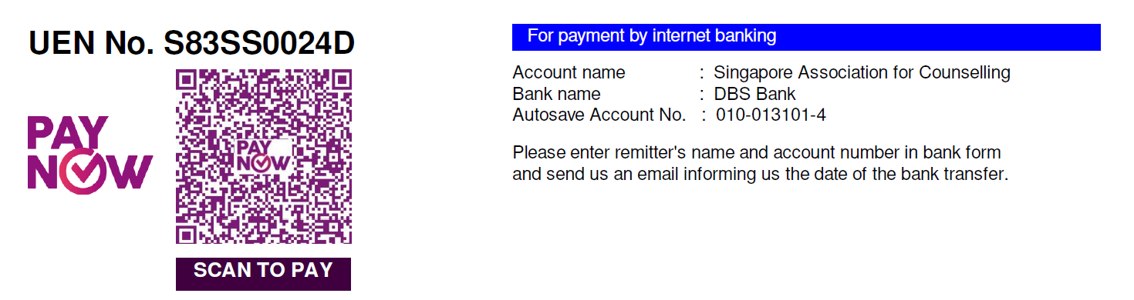

For Official Use
Received by:
Date received:
Date submitted to Clinical Sup. Board:
Date of approval:
Approval status: | Approved / Not Approved

